EDGE INTELLIGENCE
LAB - 5

25MML0038
SUBHASHINI M

EDGE IMPLUSE

STEPS:
- Create an account on Edge Impulse.
- Login to the Edge Impulse platform.
- Create a new project.
- Click Data Acquisition.
- Select Connect to device.
- Choose Use mobile phone and scan the QR code.
- Connect the mobile phone as a camera.
- Capture sample images.
- Collect images for training and testing.
- Rename images with meaningful names.
- Label all images correctly.
Training -8
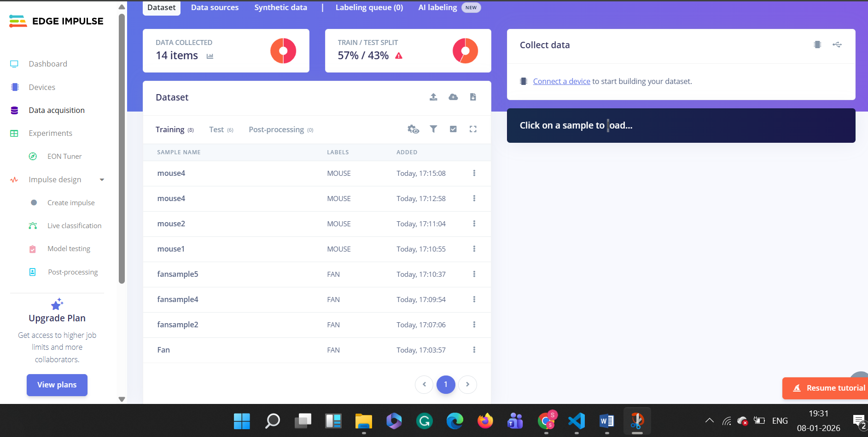

Testing-6
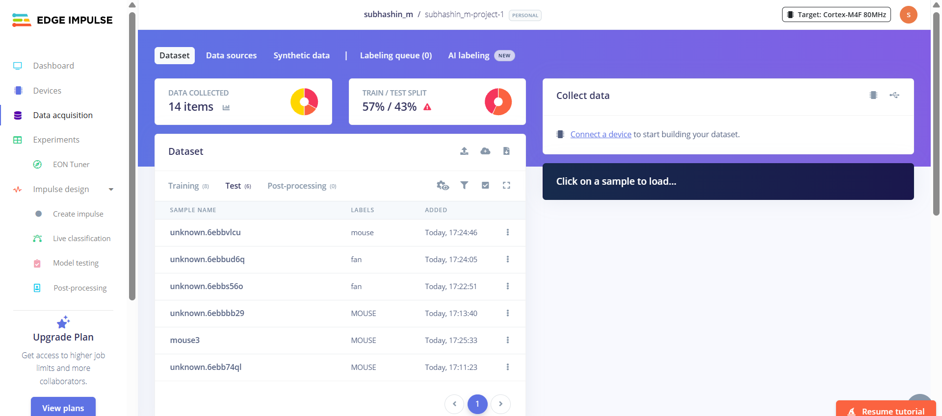

Steps to Create an Image Classification Model in Edge Impulse
- Open Impulse Design and click Create Impulse.
- Add a Processing Block as Image.
- Add a Learning Block as Image Classification.
- Click Save Impulse.
- In Impulse Design, click on Image.
- Click Generate Features to extract image features.
- After feature generation is complete, go to Image Classification (Classifier).
- Click Start Training.
- Once training is finished, the model accuracy will be displayed for the images you uploaded.

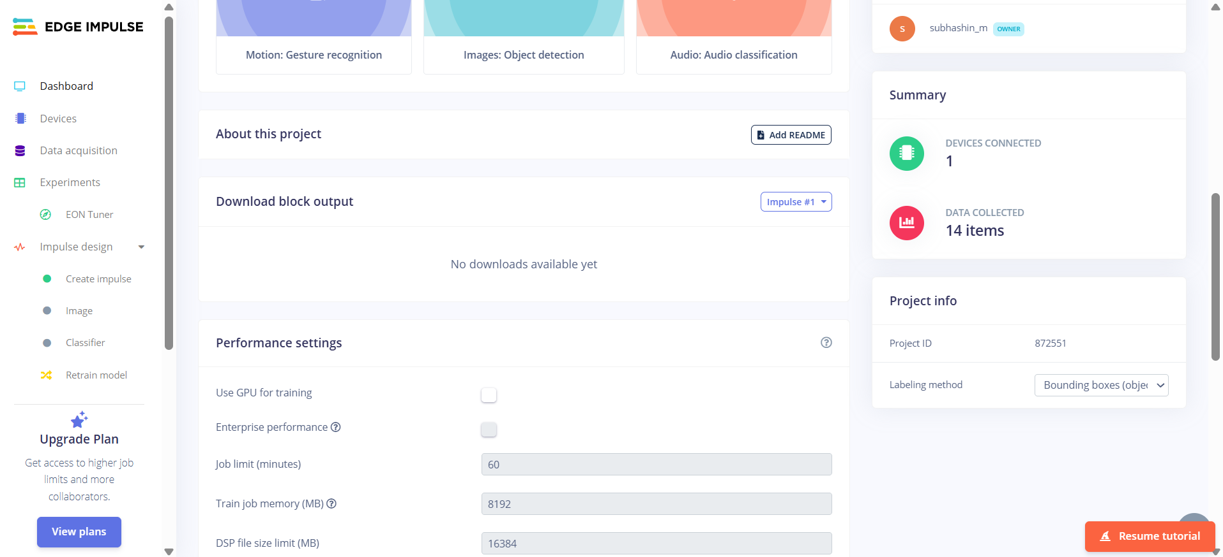

CREATE IMPLUSE
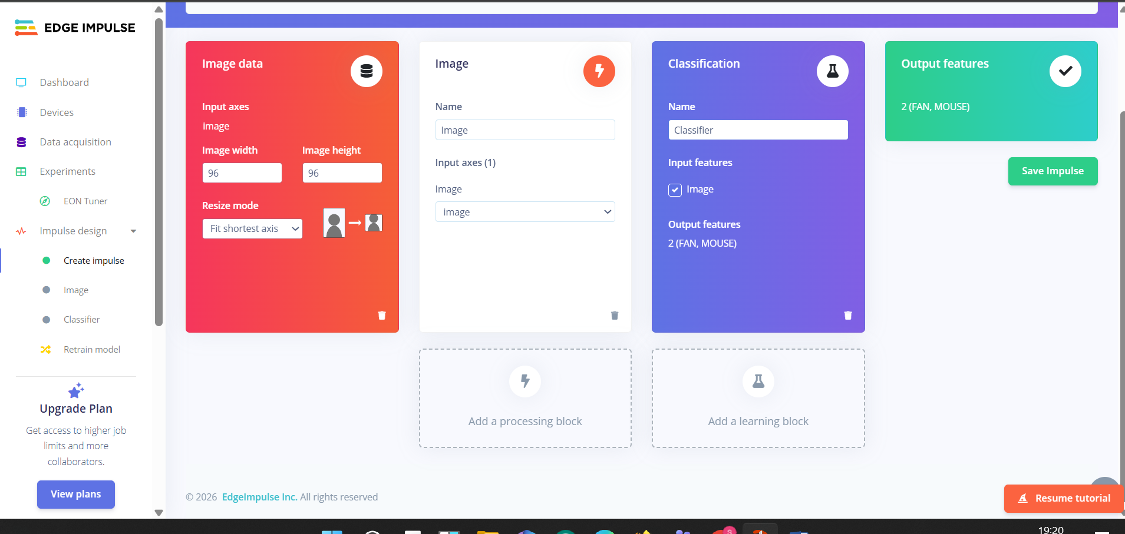

IMAGE
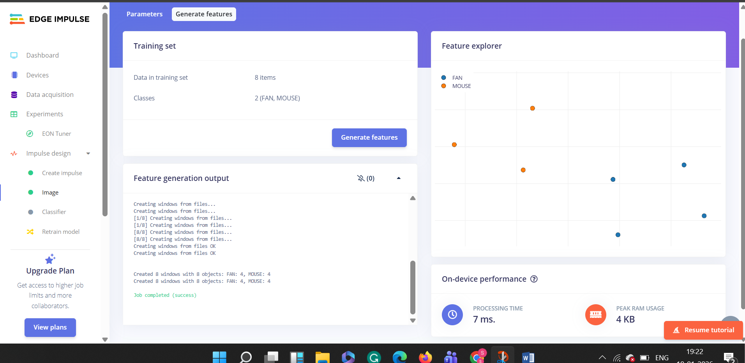

CLASSIFIER
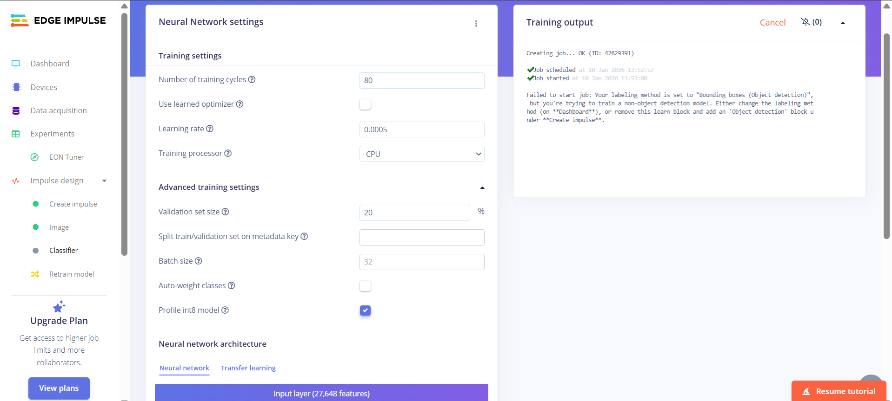

Error Fix and Image Classification Training in Edge Impulse
- An error occurred because Bounding box labeling was used with an Image Classification model.
- To fix this, go to Dashboard and change the labeling method to One label per data item.
- Properly relabel all images using single class labels (no bounding boxes).
- In Impulse Design, add Image as the processing block and Image Classification as the learning block.
- Generate features, train the model, and the classifier achieved 100% accuracy.

DASHBOARD
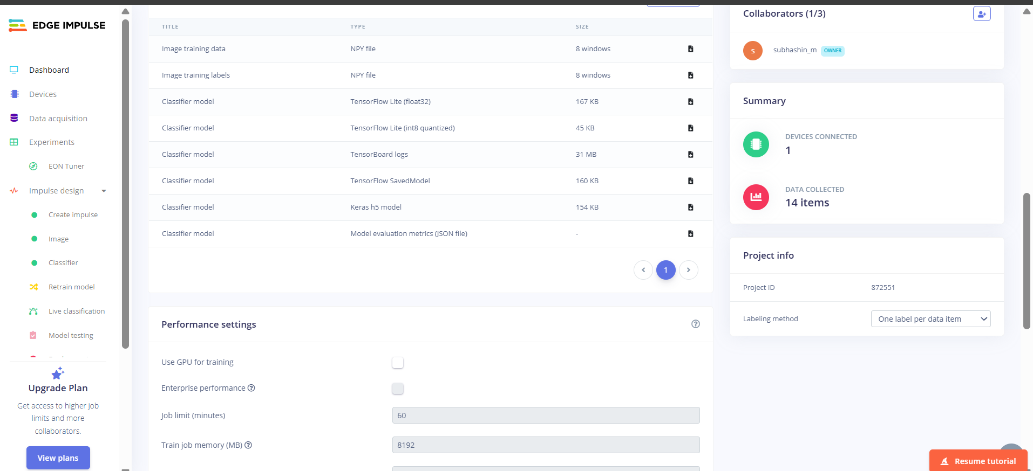
CLASSIFIER
